**Synchronous aur Asynchronous**.

**📂 FS Module – Desi Style (with Sync & Async)**

Socho tum chai bana rahe ho ☕:

* **Synchronous (Sync)** = Tum stove ke saamne khade ho, chai banne tak kuch aur nahi karoge. Sab kaam ruk gaya.
* **Asynchronous (Async)** = Tumne chai chadha di, tab tak mobile chala rahe ho. Jaise hi chai ready, awaaz aayi “ting-ting” aur tumne uthakar chai le li.

Node.js me bhi aise hi hota hai.

**1. File Banana / Write Karna**

👉 **Sync**

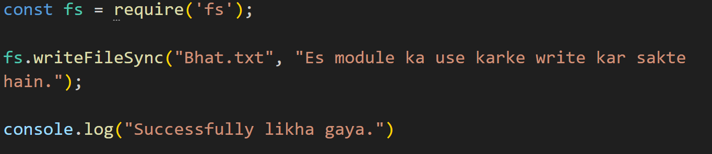

👉 **Async**

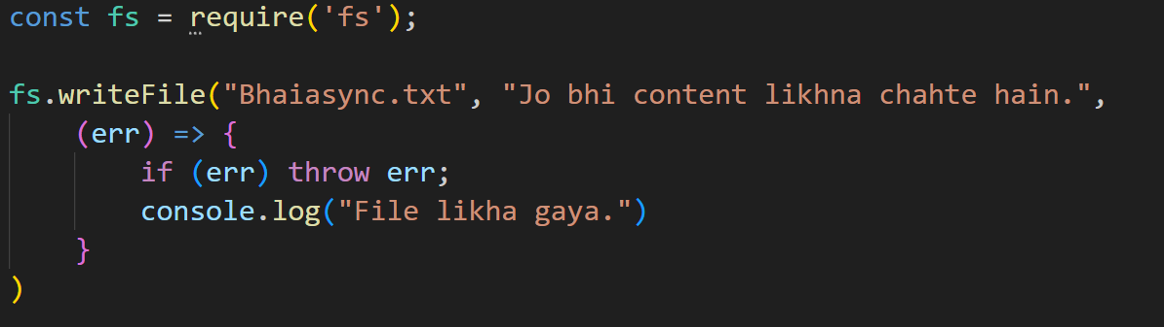

**2. File Read Karna**

👉 **Sync**

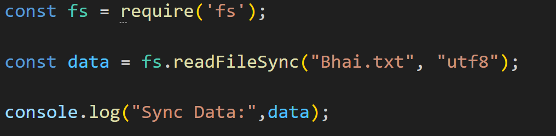

👉 **Async**

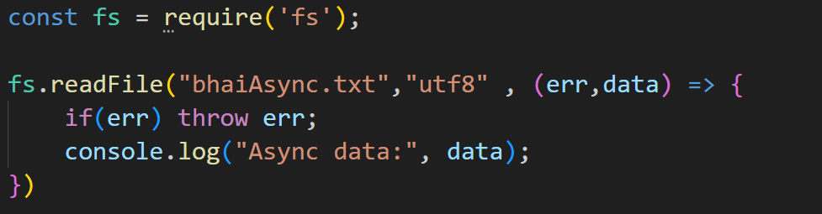

**3. File Delete Karna**

👉 **Sync**

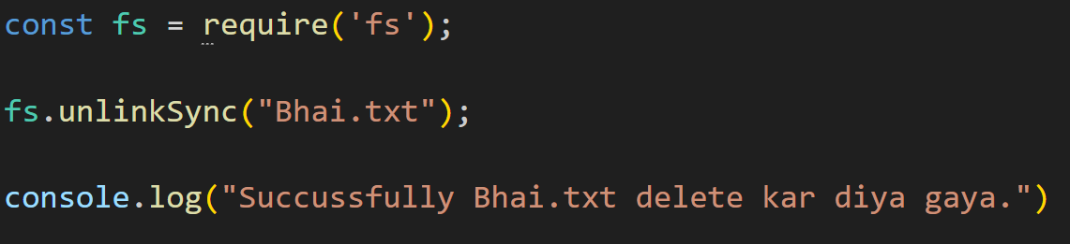

👉 **Async**

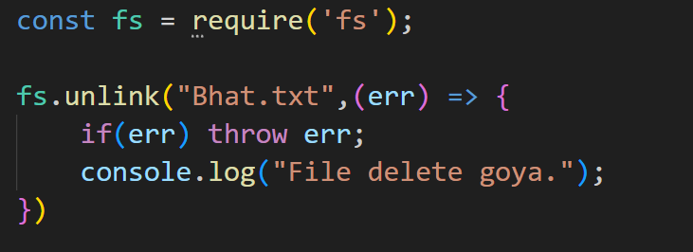

**🎯 Desi Summary**

* **Sync** → Seedha kaam karo, sab wait karega.
* **Async** → Kaam chhodo system ke hawaale, jab complete hoga callback bula lega.

**🎯 Desi Summary**

* **fs** = tumhari almirah ki master key
* writeFileSync → naya file banao ya overwrite karo
* appendFileSync → extra content jodo
* readFileSync → file padh lo
* unlinkSync → file delete kar do
* mkdirSync → folder banao
* readdirSync → folder ke andar kya hai check karo
* renameSync → file/folder ka naam badal do